BERTHING AND MOORING LEASE AGREEMENT
THIS BERTHING AND MOORING LEASE AGREEMENT (the “Lease”) is made as of this ____ day of ___________, 20__ (the “Commencement Date”), between RIVER PORT, LLC, a Virginia limited liability company, hereinafter referred to as “Landlord,” and ________________________, a _______________________ hereinafter referred to as “Vessel Owner”.
For the sole purpose of mooring the vessel(s) identified below (the “Vessel(s)”), and subject to the terms and conditions of this Lease, Landlord hereby leases to Vessel Owner and Vessel Owner hereby leases from the Landlord, for the Term set forth below, the [insert number of berthing spaces being leased] berthing space(s) on Pier(s) [Indicate if East Side or West Side of Pier 14 or East Side or West Side of Pier 15 is location of berthing space(s)] at Landlord’s terminal facility with a U.S. post office address of 1201 Terminal Avenue, Newport News, Virginia 23607 (the “Terminal”), which berthing space(s) is/are more particularly described and designated by the shading on the Landlord’s map or site plan attached hereto as Exhibit A (the “Berthing Space(s)”). Vessel Owner shall give Landlord not less than two weeks’ advance written notice of the date(s) on which the Vessels will arrive at the Berthing Space(s) (in each case, the “Scheduled Arrival Date”). Landlord may offer and provide to third parties day-to-day leases of some or all of the Berthing Space(s) to others for any or all days prior to the Scheduled Arrival Date, provided that: no such day-to-day lease for any Berthing Space shall (a) displace any Vessel(s) of the Vessel Owner already berthed in the Berthing Space(s) or (b) have a term greater than days fourteen (14) days. If Vessel Owner’s Vessel arrives prior to the Scheduled Arrival Date and there is another vessel in the applicable Berthing Space pursuant to a day-to-day lease permitted above, Landlord shall use commercially efforts to accommodate the early-arriving Vessel but shall have no liability to Vessel Owner if the Landlord is unable to accommodate the Vessel prior to the Scheduled Arrival Date. Vessel Owner’s use of the Berthing Space(s) shall be subject to, and governed by, any rules or regulations Landlord may establish from time to time for use of the piers or other facilities at the Terminal (the “Landlord’s Rules and Regulations”), which are hereby incorporated by this reference in the Lease.

Vessel and Vessel Owner Information:
Description of Vessel(s):
Vessel Owner U.S. post office address and electronic mail address for notices and invoices:
Vessel Owner Point of Contact: _________________ or other individual hereafter designated in writing by Vessel Owner
Phone: Cell Phone:
PERSONS AUTHORIZED BY VESSEL OWNER TO OPERATE VESSEL(S):
____________________________________________________________, or such other individual(s) hereafter designated in writing by Vessel Owner.

Term: The term of this Lease (the “Term”) shall be for a period of ___________ (__) months beginning on the Commencement Date; provided, however, the Term shall automatically renew for successive ___-month periods unless no less than ___________ (__) days prior to the expiration of the then-current Term, either party gives the other party written notice of its election not to renew the Term. If there are more than one Berthing Space leased hereunder, the Term shall be identical for each Berthing Space unless otherwise agreed in writing by the parties. In all events, Vessel Owner shall remove its Vessel(s) from the applicable Berthing Space(s) by no later than 4:00 p.m. local time on the last day of the Term for such Berthing Space(s), time being of the essence. Failure to vacate the applicable Berthing Space(s) by the end of the Term will constitute an event of default under this Lease and a “holdover tenancy”, subject to Landlord’s remedies set forth below.

Rent: The Vessel Owner shall pay to the Landlord for the right to use the Berthing Space(s), whether or not Vessel Owner actually makes use thereof (in whole or in part), the applicable daily lay berth (berthage) rate set forth in Landlord’s current rate sheet attached hereto as Exhibit B (the “Rate Sheet”) for each Vessel per day during the Term. The Rent for each partial or full calendar month occurring during the Term shall be due and payable on the Commencement Date and on the first day of each calendar month thereafter, in advance, without set-off or deduction, and without the need for an invoice from Landlord. Without limitation of the Landlord’s other remedies hereunder, the Rent applicable during any period of a holdover tenancy shall be twice (2X) the amount of Rent otherwise payable under the Rate Sheet for each day of the holdover tenancy, per Vessel.

Limitation of Landlord’s Liability: Vessel Owner covenants to exercise due care in occupation of the Berthing Space(s) and to vacate the Berthing Space(s) in as good a condition as delivered by the Landlord, ordinary wear and tear occasioned by normal use excepted. The Vessel Owner hereby releases the Landlord from any and all liability, loss, injury or damages to persons or property sustained by reason of the use by Vessel Owner of the Berthing Space(s) or other facilities at the Terminal other than that which is caused solely by the gross negligence or willful misconduct of Landlord. For the avoidance of doubt, Landlord shall not be liable to the Vessel Owner for any damage occurring to Vessel, including but not limited to damage arising from the acts of third parties, storms or acts of God, except such damage as results solely from the gross negligence or willful misconduct of Landlord.

“AS IS Condition”: Vessel Owner acknowledges that it has inspected the Berthing Space(s) leased herein and agrees that the Berthing Space(s) is/are adequate for Vessel Owner’s needs and purposes. The Vessel Owner accepts the Berthing Space(s) “as is”, and acknowledges that the Landlord is under no obligation to improve the Berthing Space(s). This Lease is not a bailment of Vessel Owner’s Vessel(s), but a lease of the berthing slip or mooring space constituting the Berthing Space(s). Landlord will make commercially reasonable efforts to notify Vessel Owner of dangerous conditions requiring its attention, but Landlord shall have no liability for failing to do so and Landlord assumes no responsibility for attending mooring lines or fenders or moving Vessels from or within the Berthing Space(s).

Landlord Remedies upon Event of Default: If (a) Vessel Owner fails to remove the Vessel(s) and vacate the applicable Berthing Space(s) by the end of the Term, creating a holdover tenancy, (b) any payment of Rent, Service Fees (defined below) or TPSA (defined below) due hereunder is in arrears and Vessel Owner shall fail to cure such nonpayment within seven (7) days after delivery of written notice thereof from Landlord (provided that Vessel Owner shall not have more than one cure period for nonpayment during the Term) or (c) Vessel Owner is otherwise in breach of this Lease and Vessel Owner shall fail to cure such breach within seven (7) days after delivery of written notice thereof from Landlord (provided that Vessel Owner shall not have more than one cure period for the same type of breach during the Term), or if Landlord reasonably determines that such breach constitutes an imminent danger to the property or safety of others, within such shorter period of time as Landlord shall designate in such written notice (in each case, an “event of default”), Landlord may, at its sole option, remove the Vessel(s) from the Berthing Space(s) and, at Vessel Owner’s sole risk and expense, move the Vessel(s) to a different slip, mooring space, anchorage site or dry land storage until the event of default is cured to the satisfaction of Landlord (if such event of default is capable of being cured) and Vessel Owner reimburses all expenses incurred by Landlord in connection with such event of default and the exercise of Landlord’s remedies in connection therewith. From and after the event of default, the Rent, applicable Service Fees and TPSA shall continue to accrue and remain payable on the same terms and at the same rates as provided in this Lease, except that Rent shall be double (2X) for each day of a holdover tenancy, per Vessel. Upon an event of default by Tenant, Landlord may also, by written notice to Vessel Owner, terminate this Lease, in which case all Rents, Service Fees and TPSA otherwise payable over the balance of the Term shall become immediately due and payable (except that Rent shall be double (2X) for each day of a holdover tenancy, per Vessel), and in addition to its right to remove the Vessel(s) from the Berthing Space(s) and to recover from Vessel Owner all of Landlord’s expenses incurred in connection with the event of default as set forth above, Landlord may pursue all other available remedies at law or equity.

Assignment and Subletting Prohibited: The Vessel Owner may not assign this Lease or sublet any of the Berthing Space(s), nor shall Vessel Owner berth or authorize others to berth a vessel in any part of the Berthing Space(s) other than the Vessel(s) identified above, without the prior written consent of Landlord.

Services: Vessel Owner acknowledges that Landlord and/or certain of its affiliates may, upon Tenant’s request, furnish certain services with respect to the Vessel(s) of the kind and at the rates (“Service Fees”) set forth in the Rate Sheet. Landlord shall invoice Vessel Owner for each partial or full calendar month of Service Fees no later than the tenth (10th) day of the following calendar month. Such invoices shall be due and payable to Landlord by Vessel Owner, without set-off or deduction, within ten (10) days after the date of the Landlord’s monthly invoice. Moreover, should the Vessel Owner procure ship repair services from a third-party contractor other than Landlord’s designated affiliate, Vessel Owner shall provide accurate and complete documentation of all costs incurred for labor and materials, and a Third Party Service Adjustment (“TPSA”), as a mark-up of the third-party’s charges for labor and materials, shall be immediately due and payable to Landlord in accordance with the provisions of the Rate Sheet. Landlord shall have the right to deny or approve, and reserves the right at all times to suspend or terminate, the privilege of any third-parties to come onto the Terminal to perform any services in respect of the Vessel(s).

Rules and Regulations; Guest List.

Vessel Owner agrees to comply with the Landlord’s Rules and Regulations, a current copy of which have been provided to Vessel Owner. In the event of Vessel Owner’s noncompliance with such Rules and Regulations by Vessel Owner, which noncompliance continues for ten (10) days after written notice to Vessel Owner by Landlord, such noncompliance shall constitute an event of default under this Lease, and Landlord may exercise all remedies in respect of an event of default described above in Paragraph 6.

Vessel Owner shall furnish to Landlord a proposed access list of Vessel Owner’s employees, contractors, visitors, guests and other invitees (collectively, “Invitees”) whom Vessel Owner desires to have access to the Terminal and the Berthing Space(s) for purposes of going onboard and otherwise visiting or furnishing labor and materials to the Vessel(s). Such access list shall be subject to review and approval by Landlord. Invitees other than Vessel Owner’s employees are referred to as “Guests”. In all events, Vessel Owner shall furnish to Landlord, and shall cause each of its Guests to furnish to Landlord, an indemnity and hold harmless letter in a form provided by Landlord, as a condition to receiving permission to enter upon the Terminal and/or the Berthing Space(s).

Indemnification of Landlord from Liability.

Definition of Loss: In this Lease, Loss(es) means any and all liabilities, obligations, losses, damages, penalties, fines, claims, actions, suits, judgments, settlements, fees, costs, expenses and disbursements (including without limitation reasonable attorneys’, expert witness and consultants’ fees and expenses and reasonable third party costs of investigation), of whatsoever kind and nature.

Indemnification by Vessel Owner: Vessel Owner shall defend, indemnify, and hold harmless Landlord, and any persons acting for or on behalf of Landlord or any of its affiliates, together with their respective employees, agents, partners, members, managers, shareholders, directors, officers, and assigns, from and against all Losses that directly or indirectly arise out of or relate to:

Performance of any maintenance, repair or supply of the Vessel(s);

Any acts or omissions of Vessel Owner, its agents, servants, employees, contractors, subcontractors, suppliers or vendors;

Any bodily injury, sickness, disease or death, or any injury to or destruction of tangible property arising out of or in connection with (i) the arrival, mooring or departure of the Vessel(s) at, or any Vessel’s use of, the Berthing Space(s); (ii) the entry, presence upon or travel on or across the Terminal and/or the Berthing Space by any employees, contractors, visitors, guests or other invitees of the Vessel Owner (collectively, “Invitees”); or (iii) any Invitee’s boarding or presence upon, or disembarking from, or the Invitee’s furnishing of any labor or materials to, the Vessel(s) while located at or near the Berthing Space(s).

Any failure of Vessel Owner or its agents, servants, employees, contractors, subcontractors, suppliers or vendors to comply with Landlord’s Rules and Regulations, applicable law or regulations or the conditions or provisions of applicable governmental approvals or permits;

Any insurance coverage required under Paragraph 11 below being rendered unavailable or invalidated as a result of Vessel Owner’s failure to comply with any of the requirements set forth in the applicable insurance policy or by any other act by Vessel Owner or any of its agents, servants, employees, contractors, subcontractors, suppliers or vendors ;

Any breach by Vessel Owner of any of its obligations under this Leases or any other contract or lease with any Landlord;

Any claims, liens, attachments or other encumbrances asserted against Landlord or the Terminal by any contractor, subcontractor, supplier or vendor of Vessel Owner; or

Landlord’s reasonable attorneys’ fees and other costs incurred in the enforcement of this Lease, including without limitation the Vessel Owner’s liability for increased Rent during any holdover tenancy and the Vessel Owner’s indemnity obligations hereunder.
Vessel Owner’s above indemnity obligations are intended, inter alia, to protect Landlord and its affiliates, and any persons acting for or on behalf of any Landlord or any of its affiliates, together with their respective employees, agents, partners, members, managers, directors, officers, and assigns, from and against all Losses that arise out of or relate to the Vessel(s), regardless of when the claim is made. Vessel Owner and its agents, servants, employees, contractors and subcontractors shall have no claim for Losses against Landlord or any of its affiliates or any person acting for or on behalf of Landlord or any of its affiliates, together with its respective employees, agents, partners, shareholders, members, managers, directors, officers, and assigns for the acts or omissions of Landlord or any of its affiliates or any person acting for or on behalf of Landlord or any of its affiliates unless such Losses result solely from Landlord’s gross negligence or willful misconduct; and should this exculpatory clause be declared invalid or unenforceable by law, such invalidity or unenforceability shall in no manner affect or invalidate any or all other foregoing provisions in this Paragraph 10.

Waiver of Worker’s Compensation Immunity: It is expressly understood and agreed that the indemnification of Landlord by Vessel Owner as set forth in Paragraph 10.2 above shall include and extend to any and all Losses incurred by Landlord associated with allegations, claims, actions, causes of action and suits brought by any person employed directly or indirectly by Landlord, any of its affiliates or Vessel Owner, or anyone for whose acts Landlord, its affiliate or Vessel Owner may be liable, and such indemnification obligation shall not be subject to any limitation, bar, immunity, defense or other impediment arising from or relating to worker’s compensation acts, disability benefit laws or regulations or other employee benefit laws or regulations.

Non-Payment Claims and Liens: Vessel Owner shall indemnify and hold harmless Landlord and its affiliates (in each case, a “Lien Indemnitee”) and defend each Lien Indemnitee from and against any and all Losses arising out of any and all claims for payment, whether or not reduced to a lien, asserted or filed by Vessel Owner or any of its contractors, subcontractors, vendors, suppliers or other persons performing any work on the Vessel(s), including but not limited to reasonable attorneys’, expert witness and consultants’ fees and expenses and reasonable third party costs of investigation incurred by such Lien Indemnitee in discharging any such liens or claims. If Vessel Owner shall fail to discharge promptly any such lien or claim filed against a Lien Indemnitee’s property, or any interest therein, or upon any materials, equipment, or structures encompassed therein, then Lien Indemnitee may so notify Vessel Owner in writing, and Vessel Owner shall then immediately satisfy, settle or otherwise cause the release (by bonding or otherwise) of all such liens and claims. If Vessel Owner does not promptly satisfy, settle or otherwise cause the release of such liens or claims, the Lien Indemnitee shall have the right, at its option, after written notification to Vessel Owner, to cause the release of, pay, or settle such liens or claims, and the Lien Indemnitee at its sole option may require Vessel Owner to pay, within five (5) days after request by such Lien Indemnitee, all Losses incurred by such Lien Indemnitee in causing the release of, paying, or settling such liens or claims, including administrative costs, reasonable attorneys’ fees, and other expenses. Vessel Owner shall have the right to contest any such lien or claim, provided it first provides to the Lien Indemnitee a bond or other assurances of payment reasonably satisfactory to the Lien Indemnitee in the amount of such lien or claim and in form and substance reasonably satisfactory to the Lien Indemnitee.

Insurance. In addition to its obligations in the foregoing paragraphs, Vessel Owner, at its cost, agrees to procure and maintain occurrence-based insurance of not less than the greater of (a) $10 million and (b) $50,000 per linear foot of each Vessel, in each case per occurrence and in the aggregate against claims for bodily injury and property damage arising out of, or in conjunction with, the operation, maintenance and mooring of the Vessel(s) or the occupancy or use of the Berthing Space(s) or other facilities at the Terminal by Vessel Owner or its third-party contractor(s) or supplier(s). Such insurance shall be placed with an insurer with a current A.M. Best rating of no less than A. Such insurance coverage shall continue for the Term and thereafter for so long as Vessel Owner otherwise occupies or uses the Berthing Space(s). The specific insurance coverages required to be maintained by Vessel Owner are set forth in Exhibit C and incorporated by this reference herein. Any deductible or self-insured retention therein must be revealed to, and approved by, the applicable Landlord. At the option of Landlord, the insurer shall eliminate and void the deductible or self-insured retention, as applicable, or reduce it to levels approved in writing by Landlord. The insurance shall provide coverage to Landlord and its affiliates, officers, directors, managers, members, employees and agents as additional insureds. The insurance shall be primary in respect of Landlord and its affiliates, officers, directors, managers, members, employees and agents. Vessel Owner agrees that any insurance or self-insurance maintained by Landlord, its affiliates, officers, directors, managers, members, employees and agents, shall be excess of Vessel Owner’s insurance and shall not contribute to it. Vessel Owner’s insurance shall be endorsed to waive all rights of subrogation against Landlord and its affiliates and shall state that coverage thereunder shall not be canceled or modified, except upon thirty (30) days prior written notice to Landlord. Before Vessel Owner occupies or uses the Berthing Space(s), Vessel Owner must furnish Landlord with original certificates and amendatory endorsements effecting the coverage required herein. Notwithstanding the preceding sentence, Landlord retains the right to require complete, certified copies of all required insurance policies, including endorsements effecting the coverage required hereunder.

Severe Weather; Damage to Berthing Space(s) Notwithstanding any provision herein to the contrary, by giving written notice to Vessel Owner, Landlord may elect to defer the Commencement Date of the Term, or to cancel and terminate this Lease, all without liability to Vessel Owner, in the event of damage or destruction to all or any part of the Berthing Space(s) or other facilities at the Terminal, or the reasonably anticipated threat thereof, prior to the arrival of the Vessel(s) in the Berthing Space(s) due to hurricane, storm or other severe weather, accident, vessel collision, terrorist act, sabotage, hostilities, act of God or other casualty or other occurrence beyond the reasonable control of Landlord (“Event of Force Majeure”). In the event the Commencement Date is deferred, the Lease and Vessel Owner’s obligations hereunder shall remain in full force and effect, with the Term deemed to commence on the date that Landlord designates as the new Commencement Date and to end on the expiration date designated in Landlord’s notice (which shall not be earlier than the original date for the end of the Term). If Landlord elects to cancel and terminate this Lease prior to Vessel Owner’s occupancy of the Berthing Space(s), then all obligations of the parties hereunder shall be null, void and terminated. If the Event of Force Majeure is reasonably anticipated to occur or actually occurs after the arrival of the Vessel(s) in the Berthing Space(s), then Vessel Owner shall comply with all reasonable instructions of Landlord with respect to securing the Vessel(s) or removing the Vessel(s) to a safer location, failing which the Vessel Owner shall indemnify and save harmless Landlord from and against all liabilities, costs, expenses, claims and other losses incurred by Landlord (including without limitation repair and reconstruction costs) resulting from Vessel Owner’s failure to comply with Landlord’s instructions. No Event of Force Majeure shall excuse Vessel Owner’s nonpayment or late payment of Rents, Service Fees and/or TPSA otherwise coming due hereunder.

Intended Beneficiaries. Landlord’s successors, assigns and affiliates are intended beneficiaries of the Vessel Owner’s indemnification obligations under this Lease and shall be entitled to enforce such provisions for their own account and for the account of their respective officers, directors, managers, members, employees and agents.

Notices: All notices given to either Landlord or Vessel Owner hereunder must be in writing and delivered by certified or registered mail, return receipt requested, postage prepaid, or by nationally-recognized overnight courier service, or by electronic mail and confirmed by hard-copy notice delivered as described above, in each case addressed to either Landlord or Vessel Owner, as applicable, at the U.S. post office address and/or electronic mail address for each set forth above in this Lease. Any such notices may also be given to such other U.S. mail addresses or electronic mail addresses as Landlord or Vessel Owner may designate in writing to the other from time to time in the manner prescribed above and in all cases shall be deemed given on the date the same is mailed or delivered in accordance with the provisions of this Paragraph 14.

Entire Agreement: This Lease constitutes the sole and entire agreement between the parties with respect to the subject matter hereof and no modification of this Lease shall be binding upon the parties unless evidenced by an agreement in writing signed by Landlord and Vessel Owner after the date hereof.

Successors and Assigns: The covenants, conditions and agreements contained in this Lease shall be binding upon and inure to the benefit of the parties hereto and their respective heirs, executors, administrators, successors and assigns as may be permitted hereunder.

Relationship of Parties: Nothing contained in this Lease shall be deemed to constitute or be construed to create the relationship of principal and agent, partnership, joint ventures or any other relationship between the parties hereto other than the relationship of lessor and lessee.

Further Assurances: The parties hereto agree (a) to furnish upon request to each other such information, (b) to execute and deliver to each other such other documents, and (c) to do such other acts and things, all as the other party may reasonably request for the purpose of effectuating the intent of this Lease and any documents executed pursuant hereto or in connection herewith or of complying with any law, rule, regulation, or other requirement of any governmental entity.

Non-Waiver: The failure of any party to insist in any one or more instances upon strict performance of any obligation of another party under this Lease shall not be deemed to be a waiver of the performance of any such obligation or a relinquishment of any rights hereunder for the future.

Governing Law and Venue. This Lease shall be governed by, and construed in accordance with, the laws of the Commonwealth of Virginia. Landlord shall be entitled to enforce this Lease in any federal or state court of competent jurisdiction in Newport News, Virginia. Vessel Owner irrevocably submits to the jurisdiction and venue of such court(s).

Counterparts: This Lease may be executed in several counterparts, each of which shall be deemed to be an original copy and all of which taken together shall constitute one agreement binding on all parties hereto, notwithstanding that the parties shall not have signed the same counterpart. Counterparts may be delivered via facsimile, email (including PDF or any electronic signature complying with the U.S. federal E-SIGN Act of 2000) or other transmission method, and any counterpart so delivered will be deemed to have been duly and validly delivered and be valid and effective for all purposes.
IN WITNESS WHEREOF, the undersigned have executed or caused this Lease to be executed as of the date and year first above written.
[INSERT NAME OF VESSEL OWNER] RIVER PORT, LLC
By: By:
Title: Title:
Date: Date:

EXHIBIT A
Berthing Space(s)
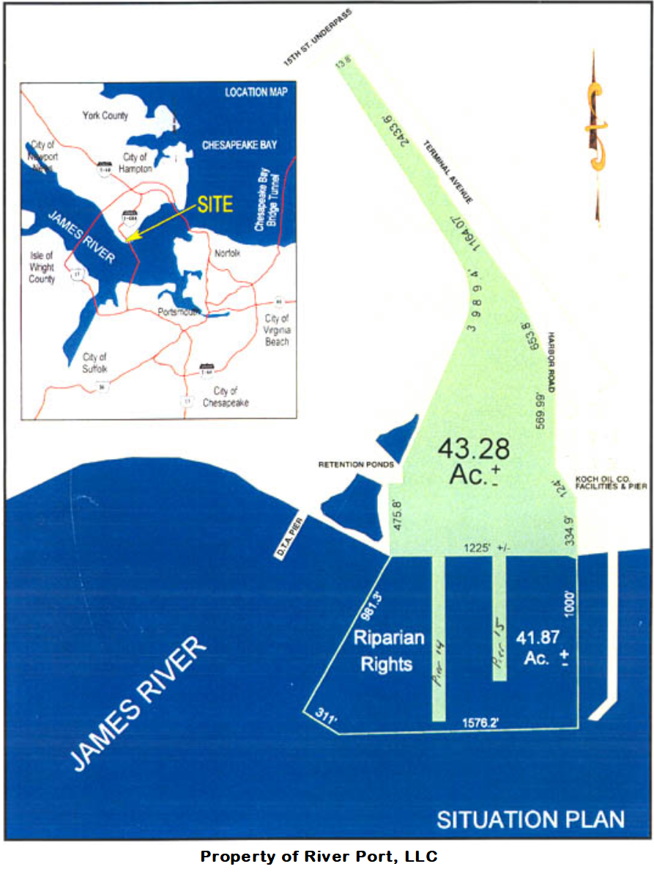

See attached Survey for specific “Berthing Space(s) leased pursuant to Commercial Lease Agreement”

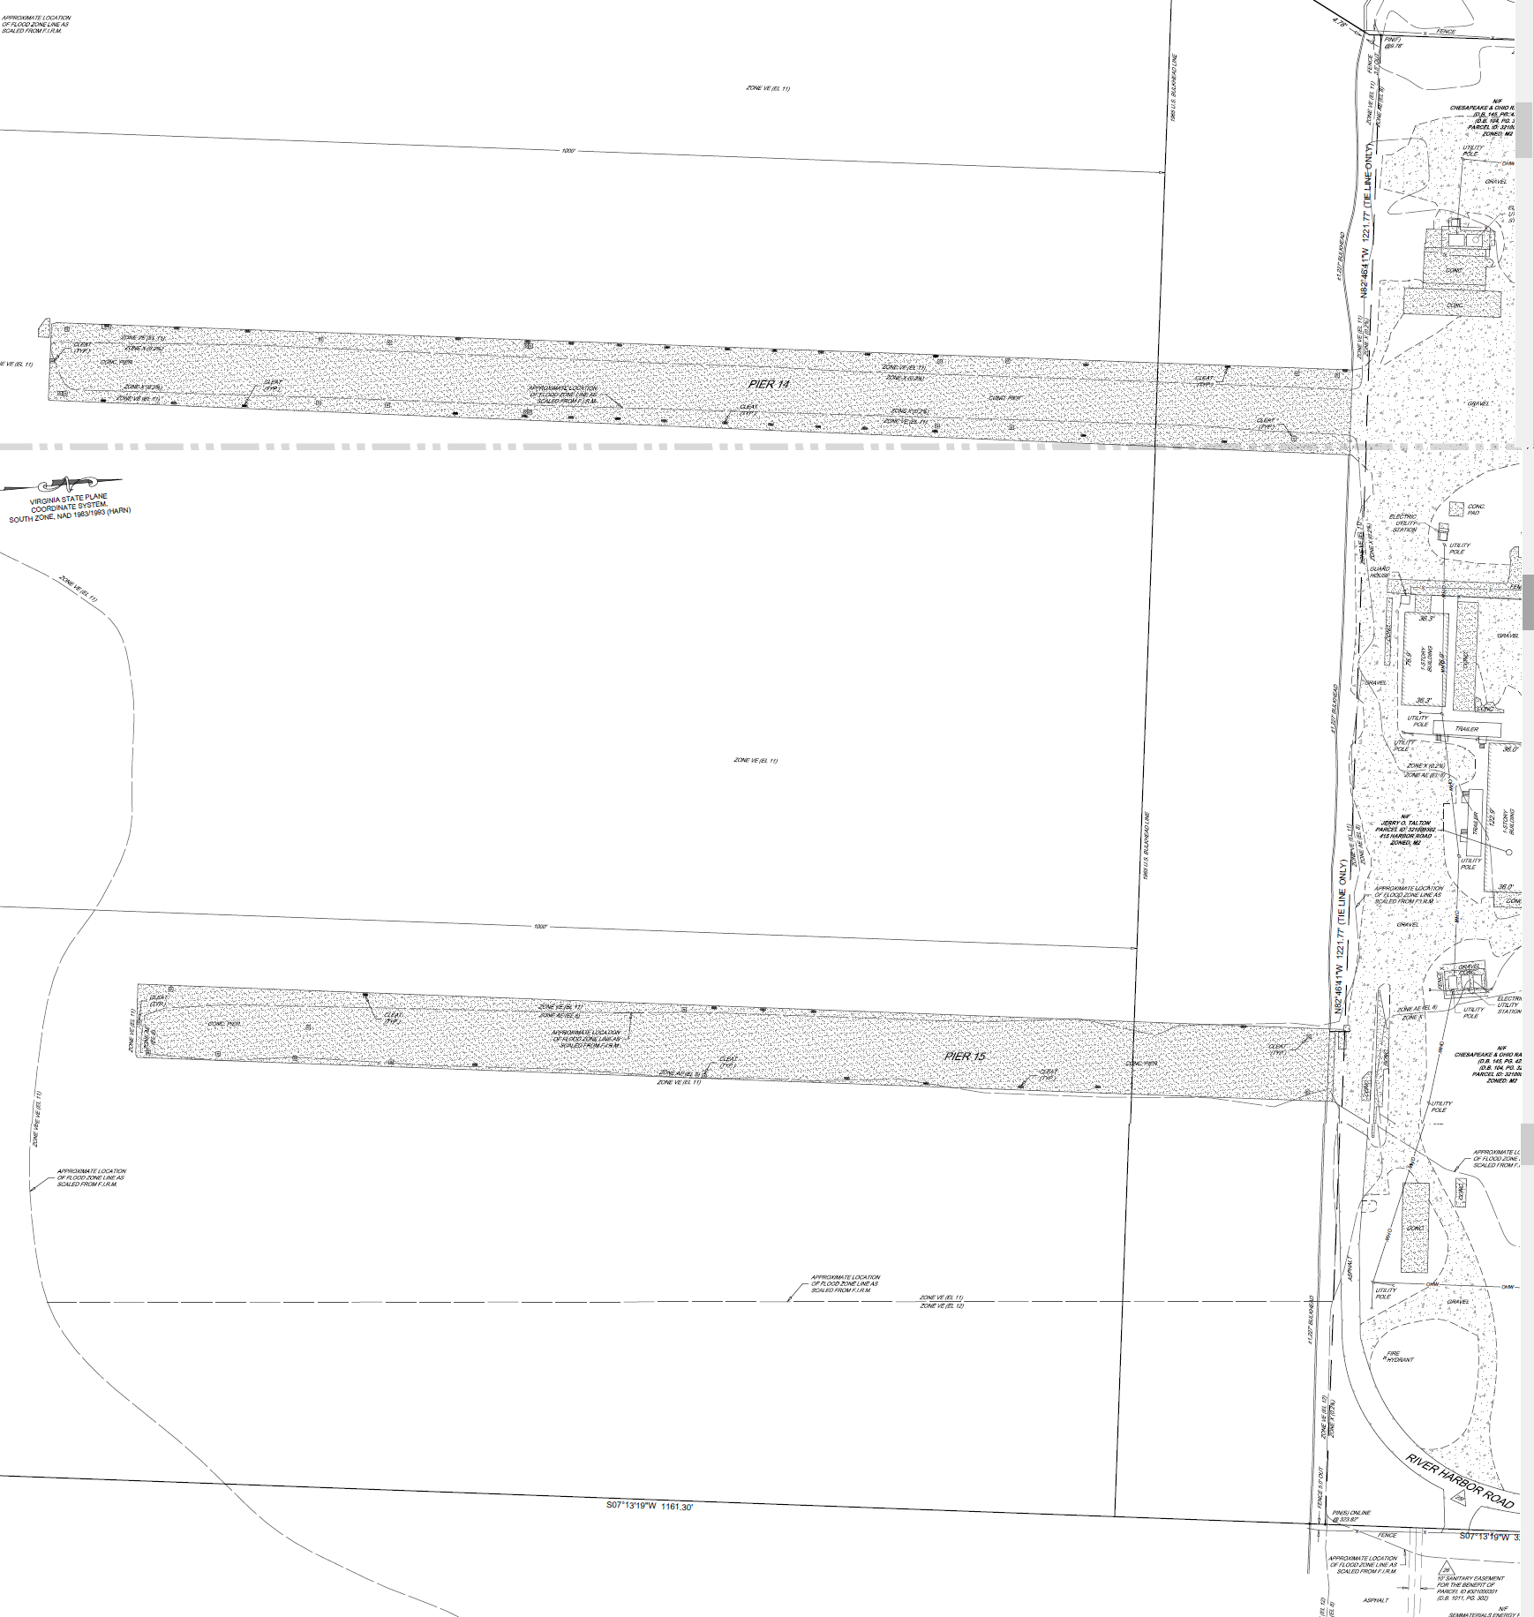
Pier 15 East Side
Pier 15 West Side
Pier 14 West Side
Pier 14 East Side

EXHIBIT B
Rate Sheet
Rates**
Labor Straight time: $___/hr, Overtime: $___/hr

Markup on Landlord’s costs for materials and contractors/subcontractors: ___%

Third Party Service Adjustment (TPSA) payable to Landlord for third party contractors utilized by Vessel Owner: ____% Mark-Up
** (this applies to any work being performed by others at Landlord’s facility; it does not apply to Tec Reps but does apply to Tec Rep support labor).

Berthage
Daily Lay berth rate for layup/mooring: $________ per day, subject to 2X increase during any holdover period.
(In the event Landlord or its designated affiliate is contracted to do work while Vessel is locate at our Facility, the lay berth rate may be reduced based on negotiated work.)

Security
Security will be charged (if requested) at Cost Plus ___%
When no security is required Landlord’s facility will remain closed during non-working hours.

Shore Power
Labor to implement shore power connections will be charged at the applicable labor rates above and will be based on T&M. If special connections are needed, Vessel Owner is responsible for cost of special connections. Vessel Owner is responsible for all usage charges and other fees of the utility provider.
In the event of loss of power, Landlord will work in good faith to reestablish service as quickly as reasonably possible.
There will be no set-off, deduction or charge-back for loss of power.

Potable Water
Labor for shore water connections will be charged at the applicable labor rates above and will be based on T&M. If special connections are needed Vessel Owner is responsible for cost of special connections. Vessel Owner is responsible for all usage charges and other fees of the utility provider. In the event of loss of water, Landlord will work in good faith to reestablish service as quickly as reasonably possible.
There will be no set-off, deduction or charge-back for loss of water.

Gray Water and Sewage Disposal
No disposal to the water is permitted. If needed We can provide a Tanker Truck at Cost Plus ______%

Line Handlers
If requested, line handling will be charged at the applicable labor rates above and will be based on T&M.
Customer to provide all lines.

Garbage Disposal
One 5 cubic yard dumpster serviced twice weekly: $_____/week

Environmental Boom
Oil Spill Containment Boom: $_____/day/vessel

Vessel Crane Service
60 ton: $_____/hr with operator, 4 hour minimum.
Insurance Requirements for:

- Vessel Owners/Managers Berthing Vessels at docks/piers owned by S23 Holdings, LLC / River Port, LLC & Affiliates

1. Insurance Company Criteria
Vessel Owner/Manager agrees to procure and maintain for the term of the contract of the berthing/mooring, at its expense, insurance with insurance companies authorized and licensed to do business in the state, province or country where the services or work will be performed having at least an A.M. Best’s rating of A – VIII, covering all operations under this agreement, with the kinds and in the minimum amounts required, under the contract as set forth below.

2. Coverage Requirements
COVERAGE | MINIMUM LIMITS
i. Marine Liability and Vessel and Crew Liability including:  ☒Bodily Injury and Property Damage  ☒Contractual Liability  ☐Ship Repairer’s Legal Liability  ☒Other | ☒$1,000,000 Combined Single Limit (CSL) occurrence  ☒Other  Including: Protection & Indemnity, Collision Liability, Wharfingers’ Legal Liability, Terminal Operators’ Legal Liability, Vessel Pollution Liability
ii. Vessel/Hull and Physical Damage Coverage including machinery & equipment | Full Value of Vessel and her machinery & equipment
iii. If used in the performance of vessel owner’s docking or mooring, Comprehensive Automobile Liability Insurance including bodily injury and property damage coverage for:  ☒Owned, hired and non-owned automobiles | ☒$1,000,000 Combined Single Limit (CSL) occurrence  ☐Other
iv. Bumbershoot, and/or Excess Liability, which will extend to cover excess limits over Protection & Indemnity, Marine General Liability and Commercial Auto Liability coverages above  ☒Yes  ☐No  ☒Where maritime employment is involved the following are required: Excess and/or Bumbershoot Liability | If needed to meet required limit:  ☐1,000,000  ☐2,000,000  ☐3,000,000  ☐5,000,000  ☒Other  Other: $50,000 per linear foot of vessel, subject to a $9,000,000 minimum
v. Worker’s Compensation including:  ☒All States Coverage/Endorsement  ☒Where work or service will be performed or originate on a US Defense Base, the following is required:  - Defense Base Act coverage  ☒Where maritime employment is involved the following are required:  ☒Longshore and Harbor Workers Compensation  ☐Outer Continental Shelf Act  ☒Maritime Employers Liability  ☒Jones Act | Statutory coverage as required by the laws of the state(s), province(s) or country(s) in which the services or work are to be performed.  Federal coverage as required by the laws and regulations of United States Department of Labor
vi. If Vessel Owner is providing a Professional service, such as Gas-Freeing, Engineering, or other similar service, then Professional liability, covering the Vessel Owner, for the negligent performance of its service, Engineering/Design, or other Professional Service, is required.  ☒Yes  ☐No | ☒$1,000,000 each claim  ☒$1,000,000 aggregate

3. Copies of the following endorsements must be included with the Vessel Owner/Manager’s Certificate of Insurance:
- Additional Insured Wording:
  - Vessel Owner/Manager shall name S23 Holdings, LLC / River Port, LLC & Affiliates as additional insureds under its General Liability and Bumbershoot Liability policies.
- Waiver of Subrogation Requirement:
  - Vessel Owner/Manager shall waive subrogation against S23 Holdings, LLC / River Port, LLC & Affiliates under its General Liability, Bumbershoot Liability and Workers Compensation policies.

- Primary and Non-Contributory Requirement:
  - It is agreed that Vessel Owner/Manager General Liability and Bumbershoot Liability policies shall be considered primary and non-contributory of any other valid and collectible insurance carried by S23 Holdings, LLC / River Port, LLC & Affiliates.
4. Cancellation Provision
Vessel Owner/Manager agrees that each insurance policy shall contain an endorsement that provides for at least thirty (30) days prior notice to S23 Holdings, LLC / River Port, LLC & Affiliates, in the event of any cancellation. Where mooring services provided are for Government contracts, the policies shall also contain an endorsement that cancellation or material change in the policies, adversely affecting the interest of the Government in such insurance, shall not be effective unless the Task Order Contracting Officer approves such cancellation or change. Vessel Owner/Manager agrees not to amend or modify its insurance policies or certificates of insurance where such amendments or modifications would reduce coverage amounts below the requirements of this Agreement.

5. Evidence of Insurance
Prior to berthing or mooring of a vessel, Vessel Owner/Manager shall furnish S23 Holdings, LLC / River Port, LLC & Affiliates with certificates of insurance to evidence Vessel Owner/Manager’s compliance with the insurance requirements of this agreement. Renewal certificates of insurance shall be provided to S23 Holdings, LLC / River Port, LLC & Affiliates prior to the expiration dates of the required insurances. The Certificate Holder shall be S23 Holdings, LLC / River Port, LLC & Affiliates.

6. Additional Requirements for Government Contractors
Vessel Owner/Manager shall also comply with any terms set forth in FAR clause 52.228-7 entitled “Insurance-Liability to Third Persons” which are in addition to those requirements contained herein.
In addition, based on the mooring agreement, S23 Holdings, LLC / River Port, LLC & Affiliates may reasonably require additional insurance coverages and/or limits.
7. No Relief
Neither failure of Vessel Owner/Manager to comply with any or all of the insurance provisions of this agreement, nor the failure to secure endorsements or policies as may be necessary to carry out the terms and provisions of this contract, shall be construed to limit or relieve the Vessel Owner/Manager from any of its obligations under this agreement.

Ed. 03012021

18392557.v4

